SUPPLEMENT SKILLS FOR THE DEVELOPMENT OF THE
UNEVEN BARS (FOR THE ALL OPTIONAL GIRLS)

1. FLOOR BAR (numbers of each exercise will be announced by personal coach):

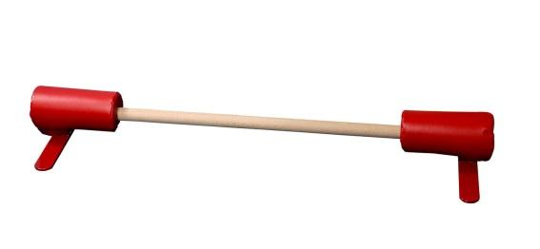
- Kick to handstand from standing position – slow motion down to the top planche with legs together/straddle ;
- Kick to handstand through the straddle from knees and from squat position laying down with pike straddle to the starting position;
- From handstand on floor bar lowing body down to the body tension;
- Body tension and top planche positions using a sliding FWD and BWD movement on Fitness Balls;
- Kick to handstand with ½ pirouette step down / and or fall onto the stomach with hollow shape;
- Kick to handstand with ½ pirouette with an extra change grip/ or and with full pirouette performed step-by-step ( with coach’s spot);
- Kick to handstand with full pirouette performed step-by-step without coach’s spot;
- From standing position kick to handstand using reverse grip – fall over onto the back with straight hollow shape;
- Using a small parallets numbers of straddle presses to handstand ( possible work using a stretched cables or stall bar;
- From reverse grip handstand – ½ turn to regular grip and fall down onto the stomach with straight hollow shape;
- Blind change technique ( shoulder FWD!) ½ turn with coach’s spot/ without spot;
- Blind full pirouette ( working safe between two incline bouncing mats);
- Healey Technique and drills: ½ pirouette from handstand on reverse grip onto the stomach and … ½ turn ending flat on the back ( on mat);
- Kick to handstand with hop changing grip from regular grip to reverse – fall down on back;
- From handstand falling down 20° -30° from high vertical - Stalder (Straddle) / or and Pike (Sole circle)/ or and Stoop working exercises using an incline mat behind the back ( the best timers supposed to be performed after ½ pirouette in handstand phase;
- Straddle/Pike/Tuck presses to handstand performed in a row (EXTREMELY NEEDED!);
- Using a bouncing mat/ or “VZ” bar trainer with bungees (JOKE!) installed with a different height gymnast have to perform a number of repetitions for the second part of Giant Circle/Free hip Circle known as EXTENDING/OPENING A SHOULDERS!

2. REGULAR FLOOR SURFACE (numbers of each exercise will be announced by personal coach):

- Extension rolls to handstand/ to high front support / to body tension/ ;
- Extension rolls to handstand with ½ pirouette using hand change and blind change technique;
- Extension rolls to handstand with ½ + ½ pirouette using hand change and blind change technique;
- Extension rolls to handstand with full pirouette using hand change and blind change technique;
- Back walkover to handstand using a kick technique ending with hollow shape in handstand;
- Back Handspring to handstand – slow down to the front support;
- Back Walkover to handstand – slow down to body tension;
- Back Handspring to handstand – slow down to the body tension;
- Holding a small bar in the hands ( by ears!) rolling movements to the candlestick moving hands down to the hips;
- Extension rolls using a penal mats ( with different height of the set) – rolls off the penal mat;
- Extension rolls using incline mat : rolling into the top of incline mat;
- Numbers of rolls through the chest to handstand using a regular surface/ incline surface ( from the top/ regular/ to the top);
- Numbers of top planche and body tension on the floor;
- Back walkover to handstand walking BWD 2-3 steps in handstand;
- Kick to handstand with hop walking 5-6 steps FWD with straight shape and absolutely extended shoulders;
- Dive Roll to handstand using a soft landing mat;
- High Back handspring to handstand using a soft landing mat;
- Laying on floor on front support position with arms bent – push-ups with hop ending to the starting position;

3/ THERA BEND/ ELASTIC/ BUNGEE: The specific set of the exercises will be attached to the Developmental Program as a number of the different pictures which will include the direction, technique and requirements.

4/ TRAMPOLINE EXERCISES (AS A PART OF THE SHAPE BUILDING):

- Regular straight jumps with increased amplitude (using a swinging BWD hands and ending the high jump with straight hollow body and arms up by ears!
- Numbers of Tuck/Pike/ Straddle/ Split jumps ending with straight hollow body and arms up by ears;
- Tuck/Pike/Straight Jump up with quarter rotation FWD with kick-out landing on stomach with straight hollow body and arms up by ears;
- Tuck/Pike/Straight Jump up with quarter rotation BWD Tuck/Pike/Straight Jump up with quarter rotation FWD with kick-out landing on stomach with straight hollow body and arms up by ears;
- ¾ Straight Salto FWD landing flat on the back with straight hollow body and arms up by ears;
- ¾ Straight Salto BWD landing flat on the stomach with straight hollow body and arms up by ears;
- Jumping FWD to handstand and rebounding with straight hollow shape BWD (kind of snap with straight hollow shape) onto the feet (the straight hollow shape without bending the body/pike is required!)
- Numbers of the sit drops with straddle legs and legs together;

5/ “Bar – Trampoline Trainer”: The most important part of this exercises are the Release Skill & Pirouettes known from the Floor bar and can be applied to the Bar-Trampoline Trainer workout!

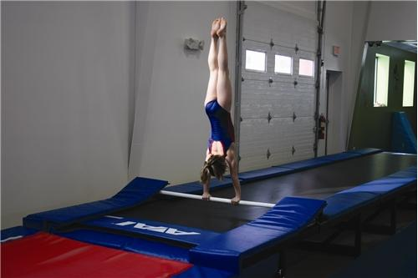

Advanced UPPER BODY Conditioning Set:

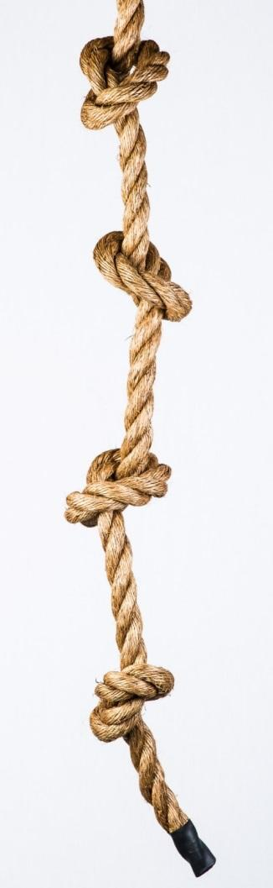
- Kip- cast – glide – kip (connections) – 15 ( 3 x 5 or 5 x 3);
- Cast to high front support – glide - kip – 15 ( 3 x 5 or 5 x 3);
- Kip cast to Handstand – 20 ( 2 x 10 );
- Cast to handstand – clear circle to handstand – 15 ( 5 sets x 3; or 3 x 5)
- Pull-ups / pull over – 20 ( 2 x 10);
- Handstand Push-ups on paralets – 20 ( 2 x 10) or Front Support Push-ups – 200 (4 x 50);
- Straddle PRESS to handstand – 25 (2 sets);
- Pike PRESS to handstand – 25 ( 2 sets);
- Body Tension (absolutely straight shape - wrists and toes support only) - 2 x 3 min;
- Top Planche Hold - 2 min or Up & Down – 2 x 25;
- Back Extension Roll starting from hollow position – 50 ( 2 x 25);
- Handstand Hold – 6 min ( 2 x 3 min);
- Sit-ups – 200 ( 2 x 100);
- Rope Climb without legs support – 2 sets;
- Rope Climb with legs support – 6 sets ( 2 x 3 in row);
- L-lever Hold on Bar (pike and straddle) – 3 min ( 2 x 1.5 min);
- V-lever Hold on Bar (pike) – 2 min ( 2 x 1 min );
- V-ups ( straddle, pike) – 200 ( 2 x 100);
- Hollow shape Hold – 3 min ( 3 x 1 min);
- Candle sticks –UP – 50 ( 2 x 25)

Comments: Upper body conditioning set must include at least 10 -12 different exercises mentioned above. Conditioning using real skills on Uneven Bars (cast / glide/ clear circle and etc.) must be performed with grips with coach’s assistance if needed.

